System Requirements
Specifications and Technical Design

The introduction starts with describing the purpose of this document and what it will cover.

1.1 Plan to Address Objectives

In your business case you specified a few objectives. These were real-world issues that your software intervention will address. In this section you need to stipulate what you will do in your software to address these objectives. E.g. the following objectives were stated in the business case:

- Replace the paper-based note-taking system used by healthcare workers with a digital alternative.
- Ensure that notes cannot get lost, by providing an off-line saving system.
- Provide a central means by which to search through historic notes.

These objectives can then be discussed as follows in this section:

In order to the replace the paper-based note-taking system used by healthcare workers, an Android-based mobile application will be developed. Android was chosen as it is the most widely used mobile operating system under the target group of healthcare workers. A mobile application will ensure that the healthcare workers have access to the system wherever they may be working from on any given day.

Because of the mobile nature of the work of these healthcare workers, they frequently lose their notes. A mobile application will be able to address this issue by saving the notes on the device itself. Since the healthcare workers may be travelling in areas with little or no access to network connectivity, it is essential to save offline copies of any notes made. Whenever the healthcare worker moves into an area with connectivity, the local notes will sync to a central server. This also ensures that if a healthcare worker loses their phone, they do not lose their notes.

Currently, if a healthcare worker needs to search through their notes, they need to search through a stack of papers. If they need to give their manager access to their notes, it involves the manager rummaging through the same stack of notes. A digital application will allow the notes to be easily searchable through a web-based interface. A web-based interface was chosen for this aspect of the solution as the healthcare workers frequently check their notes only when they are back in the office. This also allows the office-bound managers to easily access the notes of individual healthcare workers to search for trends.

1.2 Project scope

The scope must provide a high level view of data requirements. This should include a discussion on the information, functional and communication scope of the intended system. The scope of a project is very important as it sets the expectations of the project. Be realistic when setting your scope.

1.2.1 Information scope

In this section, discuss any details regarding the storage and handling of information, e.g. what will be stored, where will it be stored (on device or elsewhere) and will it be encrypted?

1.2.2 Functional scope

In this section, discuss the feature which you plan to include in the system, e.g. capturing of notes on a mobile device, searching through notes by a web interface and generating reports.

1.2.3 Communication scope

In this section, discuss how communication will take place with the system, e.g. will the system send SMSs, will it notify the healthcare worker that they are offline or that the system has synced, will it work over mobile connections or just Wi-Fi.

1.3 Business requirements

Business requirements, also known as stakeholder requirements specifications (StRS), describe the characteristics of a proposed system from the viewpoint of the system's end user. In this case, the system has two end-user types, namely healthcare workers and managers. These two user types might have different needs from the system, e.g.:

Healthcare workers require a system that is dependable and always available. It should have an easy-to-use interface to facilitate simplified note-taking while the Healthcare workers are travelling.

Managers require centralized access to the healthcare workers’ notes. The search interface should be clutter-free and allow notes to be searchable according to keywords and filtered according to date ranges.

1.4 Hardware and Software Requirements

State which hardware and software tools will be used both in developing the application and in its use, e.g:

1.4.1 Software Requirements

- The mobile application will be developed using Android Studio.
- The web application will be developed using Microsoft Visual Studio 2022.
- The mobile application will use Sqlite as its local storage medium.
- Microsoft SQL Server 2022 will be used as the shared online database.
- Connectivity between the app, the web interface and the shared database will be facilitated by developing a WCF Web service in Microsoft Visual Studio 2022.
- The mobile application requires a phone running (at least) Android 12 (Snow Cone).
- The web application will run in any browser but will be optimized for Google Chrome.

1.4.2 Hardware Requirements

- The mobile application requires a mobile phone with at least 1Gb or RAM, capable of running Android 12.
- The web application may be opened on any device with a web browser.
- The web application and SQL Server will be hosted on a shared web server.

1.5 Design constraints

In this section, discuss any constraints that there might be on the system development and / or deployment process. This can include things such as security, interface and performance constraints.

1.5.1 Security constraints

Discuss any issues related to the security of the proposed system, e.g.

The notes taken by the healthcare workers might be of a sensitive nature, as they contain information regarding patients seen by the healthcare workers. Therefore, care must be taken to encrypt the notes both on the phone and the server and to ensure that users should provide a username and password when accessing the system. The username and password should also be encrypted.

1.5.2 Interface constraints

Discuss any issue related to the interface of the proposed system, e.g.

The mobile interface needs to be user-friendly as it may be used by health care workers who are not technically savvy. The web interface should be responsive so that users have the choice to view the pages on a desktop, tablet or phone.

1.5.3 Performance constraints

The system should be optimized to ensure that searches through the web interface are fast and efficient. The mobile application should be optimized for use on low end mobile devices with low memory capacity and older processors.

1.6 High-level use case diagram

The purpose of a use case diagram in UML is to demonstrate the different ways that a user might interact with a system. A use case diagram can summarize the details of your system's users (also known as actors) and their interactions with the system.

Example:

Figure 1.1 presents a high-level use case diagram of the proposed system and its users.

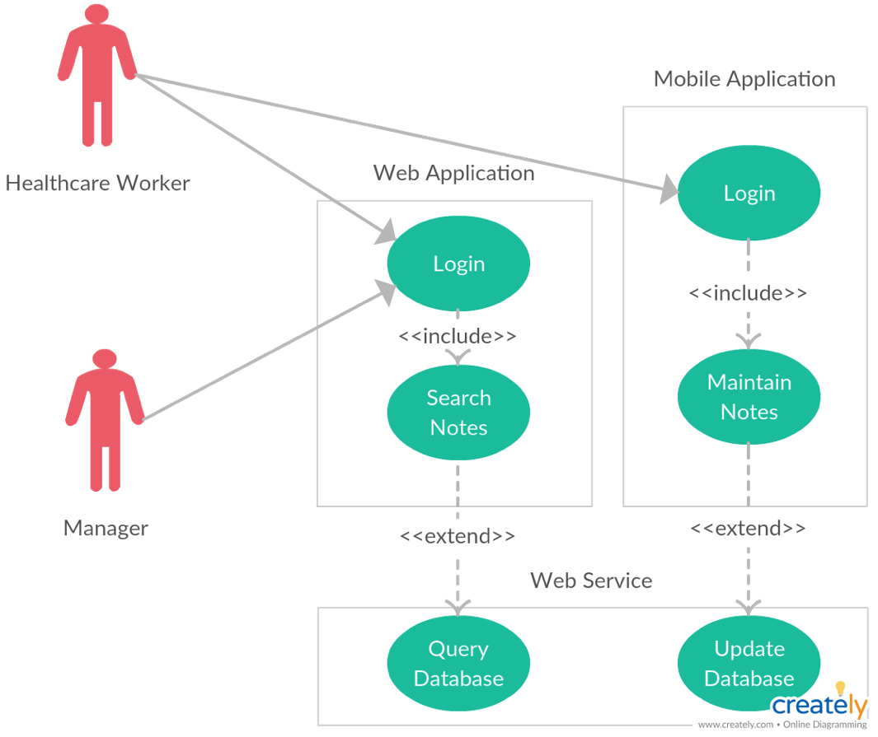
Figure 1.1 High-level use case diagram

1.7 UML Class Model / Diagram

This section should present your (planned) UML class model. If you have not yet started your system development, you may draw the diagram using a stand-alone tool, such as Visio. Alternatively, if you have already started development, you may use the class diagram created for you by tools such as Visual Studio. This does not need to be the final version of your UML class model as you’ll be able to update the diagram in your final, combined report at the end of the semester. The number of classes in your diagram tends to align with the number of tables in your database.

Example:

Figure 1.2 represents the UML class diagram of the YOURPLANNEDSYSTEMNAME system.

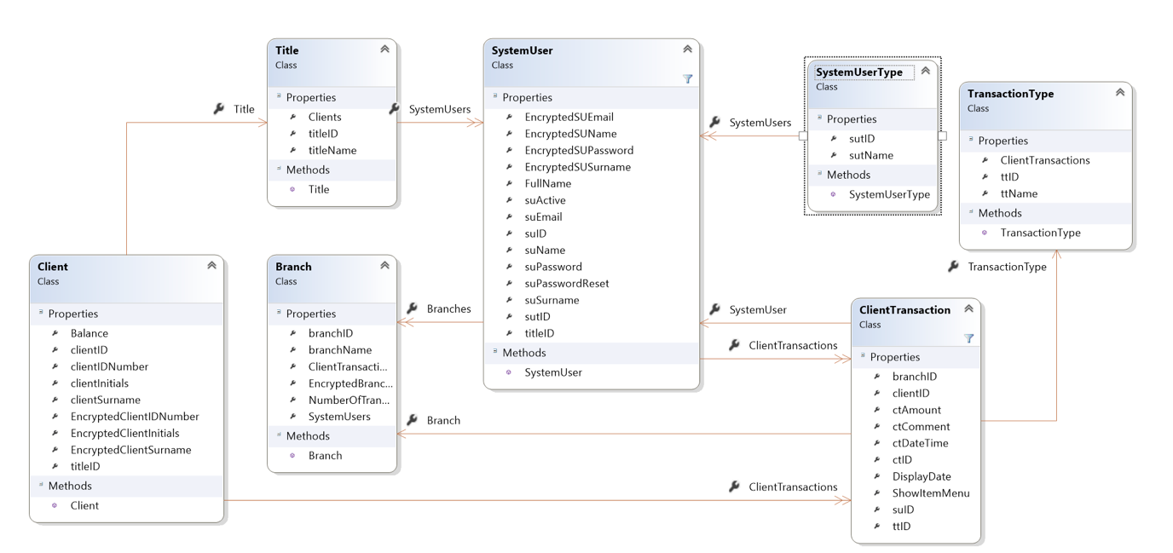
Figure 1.2 UML Class Diagram

1.8 Relational Database Model Diagram

This section should present the (planned) version of your relational database model. If you have not yet started designing your database, you may draw the diagram using a stand-alone tool, such as Visio. Alternatively, if you have already started the design, you may use the ERD created for you by tools such as SQL Server Management Studio. This does not need to be the final version of your relational database model as you’ll be able to update the diagram in your final, combined report at the end of the semester. Remember, it needs to have the absolute minimum of the equivalent of 10 tables. Groups of three students will need at least 14 tables.

Example:

Figure 1.3 represents the entity relationship diagram of the YOURPLANNEDSYSTEMNAME system.

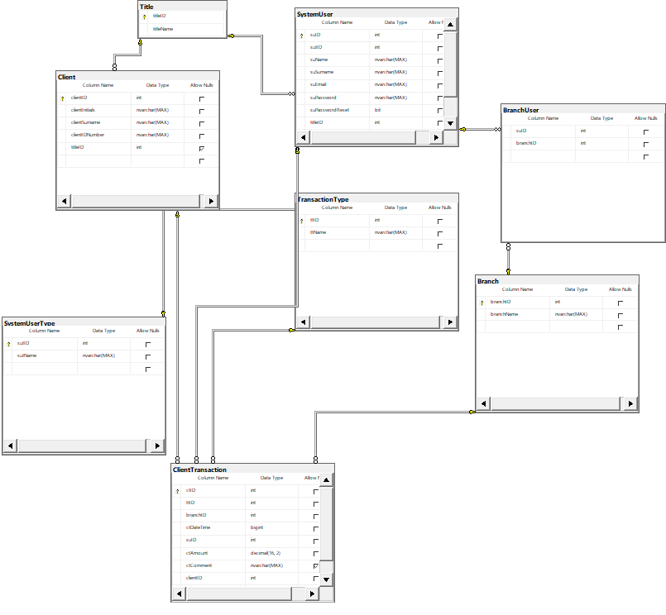
Figure 1.3 ER Diagram

1.9 User Interface Design

This section should present the user interface designs of at least 8 screens from your proposed system (10 for groups of 3). If you have a system which is more graphically driven (like a game), you can substitute screens with the designs of individual components. If you have not yet started on your system development, you may use stand-alone tools such as Visio to create simple versions of your planned screens. These can be in the form of low fidelity wireframes. Alternatively, if you have already started system development, you may take screenshots of the screens you have already completed. For each screen(or component) you are required to provide a description of the functionality. These do not need to be the final versions of these screens as you’ll be able to update the screens in the final, combined report at the end of the semester.

Example:

Figure 1.4 represents the login screen of the YOURPLANNEDSYSTEMNAME system. The screen requires that a user enter their email address (as a username) and a password. Upon successful login, the user will be redirected to the system’s landing page. The screen also provides the user with an option to use in the event that they have forgotten their password.

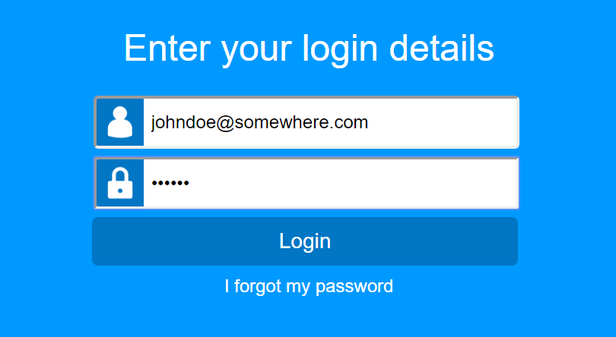

Figure 1.4 Login Screen

